**PROJECT 4 - INTERFACING ELECTRONICS WITH THE RPI**

**1. Your C, C++, or Python program, with comments.**

**Ans:**

**Python program:**

import RPi.GPIO as GPIO #importing GPIO library

import time

bit0=26 #bit 0 pin number

bit1=19

bit2=13

bit3=6

bit4=5 #bit 4 pin number

GPIO.setmode(GPIO.BCM)

GPIO.setup(bit0, GPIO.OUT) #Assignment of GPIO as an OUTPUT pin

GPIO.setup(bit1, GPIO.OUT)

GPIO.setup(bit2, GPIO.OUT)

GPIO.setup(bit3, GPIO.OUT)

GPIO.setup(bit4, GPIO.OUT)

GPIO.output(bit0, 0)

GPIO.output(bit1, 0)

GPIO.output(bit2, 0)

GPIO.output(bit3, 0)

GPIO.output(bit4, 0)

def count():

print("Counter Starts")

print("Press ctrl+c to go back to Menu")

cnt = 0

try:

while True:

GPIO.output(bit0, cnt & 0x01)

GPIO.output(bit1, cnt & 0x02)

GPIO.output(bit2, cnt & 0x04)

GPIO.output(bit3, cnt & 0x08)

GPIO.output(bit4, cnt & 0x10)

time.sleep(1)

cnt += 1 % 32

except KeyboardInterrupt:

GPIO.output(bit0, 0)

GPIO.output(bit1, 0)

GPIO.output(bit2, 0)

GPIO.output(bit3, 0)

GPIO.output(bit4, 0)

print("Counter Ends")

def r2l():

print("Right to Left Sweeping Starts")

print("Press ctrl+c to go back to Menu")

try:

while True:

GPIO.output(bit0, 1)

time.sleep(2)

GPIO.output(bit0, 0)

GPIO.output(bit1, 1)

time.sleep(2)

GPIO.output(bit1, 0)

GPIO.output(bit2, 1)

time.sleep(2)

GPIO.output(bit2, 0)

GPIO.output(bit3, 1)

time.sleep(2)

GPIO.output(bit3, 0)

GPIO.output(bit4, 1)

time.sleep(2)

GPIO.output(bit4, 0)

except KeyboardInterrupt:

GPIO.output(bit0, 0)

GPIO.output(bit1, 0)

GPIO.output(bit2, 0)

GPIO.output(bit3, 0)

GPIO.output(bit4, 0)

print("Right to Left Sweeping Ends")

def l2r():

print("Left to Right Sweeping Starts")

print("Press ctrl+c to go back to Menu")

try:

while True:

GPIO.output(bit4, 1)

time.sleep(2)

GPIO.output(bit4, 0)

GPIO.output(bit3, 1)

time.sleep(2)

GPIO.output(bit3, 0)

GPIO.output(bit2, 1)

time.sleep(2)

GPIO.output(bit2, 0)

GPIO.output(bit1, 1)

time.sleep(2)

GPIO.output(bit1, 0)

GPIO.output(bit0, 1)

time.sleep(2)

GPIO.output(bit0, 0)

except KeyboardInterrupt:

GPIO.output(bit0, 0)

GPIO.output(bit1, 0)

GPIO.output(bit2, 0)

GPIO.output(bit3, 0)

GPIO.output(bit4, 0)

print("Left to Right Sweeping Ends")

def cswp():

print("Continuos Sweeping Starts")

print("Press ctrl+c to go back to Menu")

try:

while True:

GPIO.output(bit0, 1)

time.sleep(2)

GPIO.output(bit0, 0)

GPIO.output(bit1, 1)

time.sleep(2)

GPIO.output(bit1, 0)

GPIO.output(bit2, 1)

time.sleep(2)

GPIO.output(bit2, 0)

GPIO.output(bit3, 1)

time.sleep(2)

GPIO.output(bit3, 0)

GPIO.output(bit4, 1)

time.sleep(2)

GPIO.output(bit4, 0)

GPIO.output(bit3, 1)

time.sleep(2)

GPIO.output(bit3, 0)

GPIO.output(bit2, 1)

time.sleep(2)

GPIO.output(bit2, 0)

GPIO.output(bit1, 1)

time.sleep(2)

GPIO.output(bit1, 0)

except KeyboardInterrupt:

GPIO.output(bit0, 0)

GPIO.output(bit1, 0)

GPIO.output(bit2, 0)

GPIO.output(bit3, 0)

GPIO.output(bit4, 0)

print("Continuos Sweeping Ends")

def d2b():

print("Decimal to Binary Conversion Starts")

try:

while True:

print("Press ctrl+c to go back to Menu")

print("Enter 0-31 to convert into Binary")

b=int(input())

if ((b>=0) and (b<=31)):

GPIO.output(bit0, 0)

GPIO.output(bit1, 0)

GPIO.output(bit2, 0)

GPIO.output(bit3, 0)

GPIO.output(bit4, 0)

GPIO.output(bit0, b & 0x01)

GPIO.output(bit1, b & 0x02)

GPIO.output(bit2, b & 0x04)

GPIO.output(bit3, b & 0x08)

GPIO.output(bit4, b & 0x10)

else:

for i in range(1,5):

GPIO.output(bit0, 1)

GPIO.output(bit1, 1)

GPIO.output(bit2, 1)

GPIO.output(bit3, 1)

GPIO.output(bit4, 1)

time.sleep(2)

GPIO.output(bit0, 0)

GPIO.output(bit1, 0)

GPIO.output(bit2, 0)

GPIO.output(bit3, 0)

GPIO.output(bit4, 0)

time.sleep(2)

print("Invalid Entry")

except KeyboardInterrupt:

GPIO.output(bit0, 0)

GPIO.output(bit1, 0)

GPIO.output(bit2, 0)

GPIO.output(bit3, 0)

GPIO.output(bit4, 0)

print("Decimal to Binary Conversion Ends")

while True:

print("********MENU*********")

print("\n")

print("1: Sequential count in Binary")

print("2: Sweeping light movement from right to left")

print("3: Sweeping light movement from left to right")

print("4: Continuous sweeping light movement (right to left, then left to right, ...)")

print("5: User input Decimal to Binary translation")

print("q: Quit")

print("Enter your choice (1-5) or q:")

a = input()

if a=="1":

count()

elif a=="2":

r2l()

elif a=="3":

l2r()

elif a=="4":

cswp()

elif a=="5":

d2b()

elif a=="q":

print("Program Closed")

GPIO.cleanup()

exit()

else:

print("Invalid Entry")

print("Please Enter Again")

**2. Wiring diagram of your five LED circuit.**

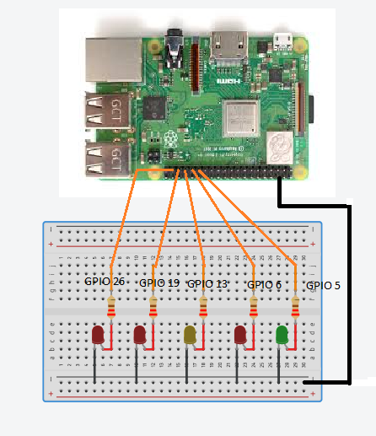

**3. Picture of your five LED circuit.**

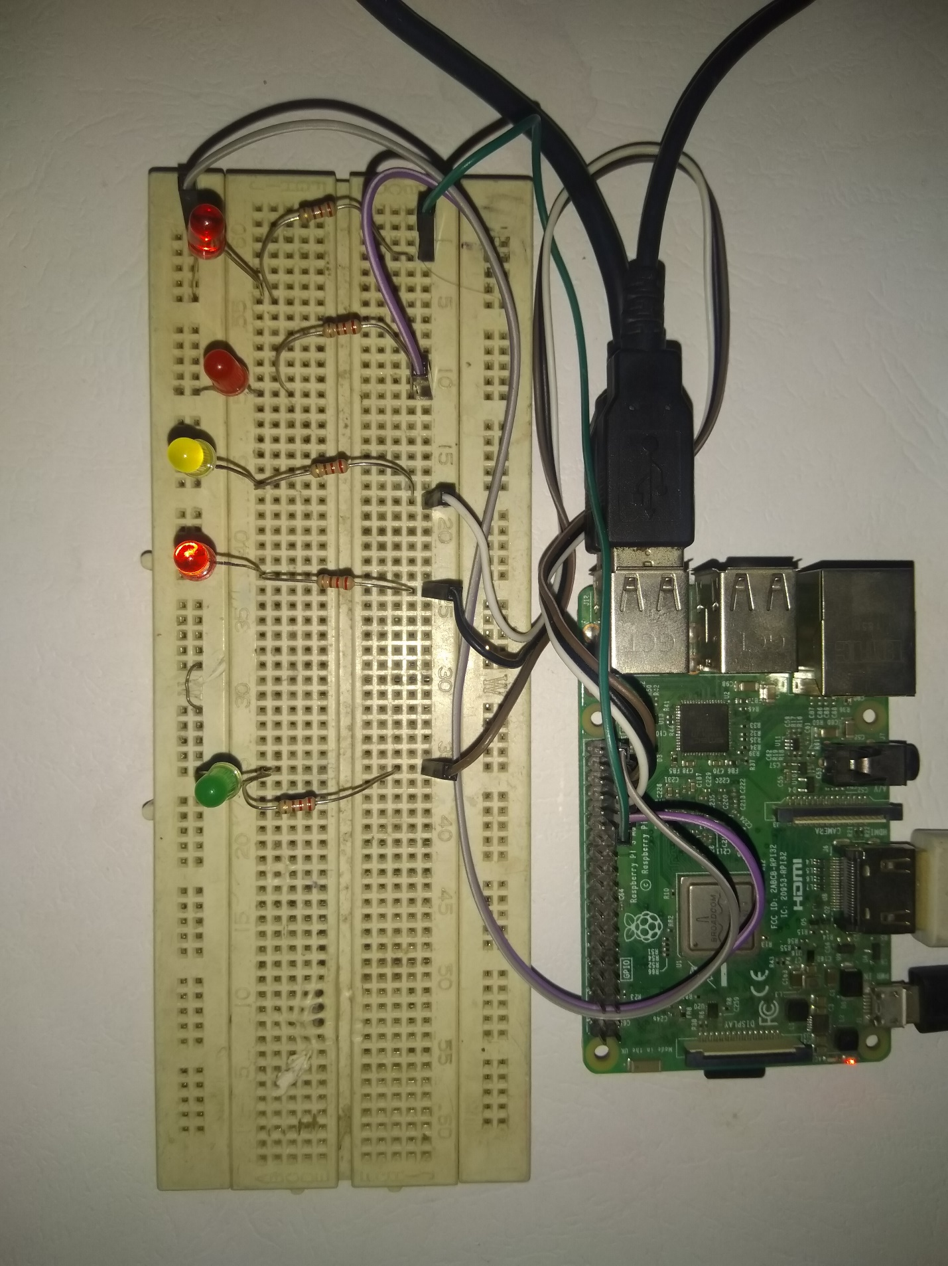

**4. Video demo of your project working with all menu options. A URL link to your video can be placed in the document. Make sure to set the permissions on your video file so that it can be viewed by anyone with the link.**

**Sol:**

<https://youtu.be/M_hU-pPeH4Q>

**5. Describe your approach to this project. List any problems that you’ve encountered and how you overcame these issues.**

**Ans:**

In this project, we have to interface electronics with our Raspberry Pi. First of all, take 5 leds of any colors and five resistances of 220 ohm. Connect these leds and resistance on breadboard in such a way that each led and resistance are in series with each other. All leds cathode are connected at one point and this common point is connected with the ground pin of the raspberry pi. The GPIO pins of raspberry Pi we are using are 5,6,13,19 & 26. Connect one end of five resistances with 5 GPIO pins of the raspberry Pi. Now the circuit connections are complete and move toward writing the python program.

Turn ON the Raspberry Pi and when Raspberry Pi starts open the Python (IDLE) compiler. Now start making program in python. First of All we have to run these leds in “Sequential count in Binary” mode so for this we have initialize 5 bits starting from 0 to 4.Initially set all these bits zero (OFF).As we have to describe five different cases in this project so we declare five functions. The function can be call at any point in the program. For first option of the program “Sequential count in Binary”, the logic use for counting is to find the remainder of the number and with increase in the iteration of program function till all division with remainder completes. After this move to the second option “Sweeping light movement from right to left”. For this option the logic we implement is first define its separate function. Within function the bits become high (ON) starting from right to left. It means fist GPIO 5 pins become high and then off for some time. Then next Pin become high and then off and so on. For third option do the same but now this time led glow from left to right. Similarly, a new function is design for new task/option to add in the program. There are two different functions to escape from the program.

The problem I encountered during making this project is Python programming. It is hard to make function for each option and call them sequentially. For solving this issue, I make functions step by step and call them to verify whether it works or not. Actually, without functions we have to make this complex program for every function.